Galvo Driver Enclsoure

Vault Folder: GALVOS

Nathan Clack

Research Specialist

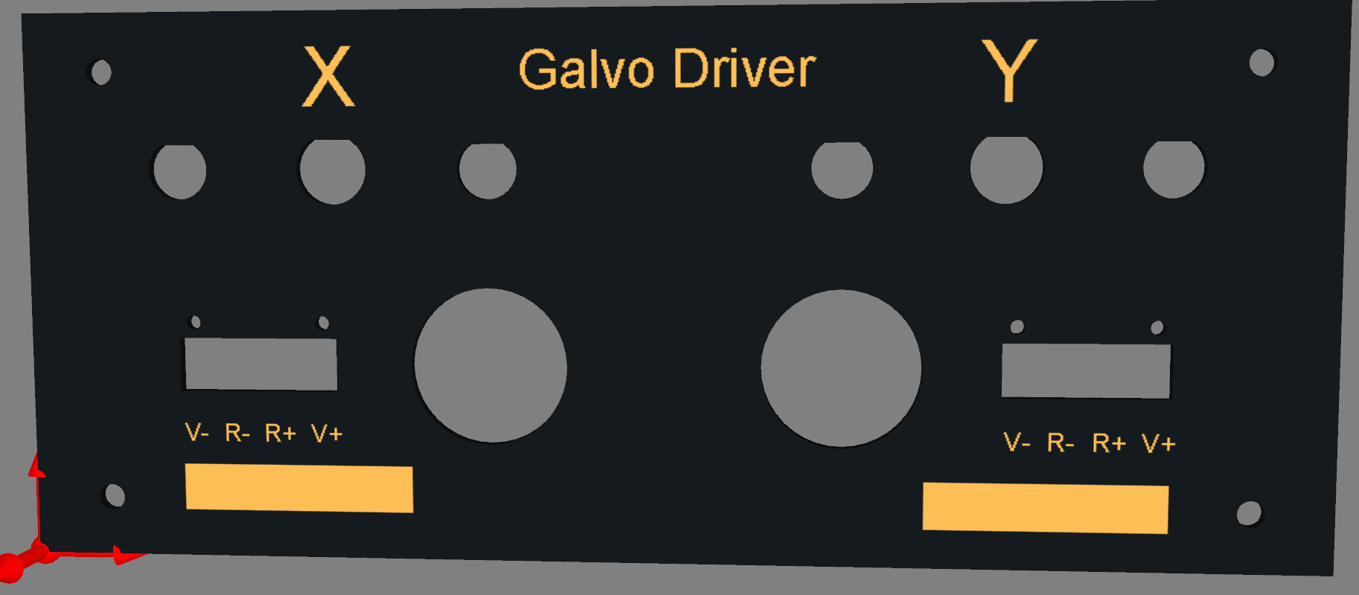

Steve Sawtelle  
Electrical Engineer, ID&F  
(571) 209-4158

Contents

System Overview 2

Hardware Development 2

Assembly, Test, and Calibration 5

# System Overview

The Galvo Driver Enclosure provides mounting, heat sink, and connectors for various Cambridge Technologies galvo drivers. One or two drivers can be mounted in the enclosure.

# Hardware Development

The Enclosure utilizes an off-the–shelf half-rack enclosure. The front panel can replaced by a custom front panel or the supplied panel can be modified to suit the particular need. The rear panel is replaced by a modular heat sink that provides various galvo mounting options. Wiring is highly dependent on the individual needs. The front panel design provides two BNCs and one Twin-Ax connectors for signal. A plug-able power supply connector is also provided for each channel. In addition a hole with grommet is provided for pass-through cables.

*Materials*

|  |  |  |  |  |  |  |
| --- | --- | --- | --- | --- | --- | --- |
| **Qty** | **Value** | **Device** | **Manufacturer** | **Manufacturer PN** | **Digi-Key PN** | **Notes** |
| 1 |  | Half-Rack Enclosure | Hammond | RMCV9038 | RMCV9038BK1-ND |  |
| 1 |  | Heat Sink | Aavid | 62725 |  | Modified per drawing |
| 1 |  | Front Panel | Proto-Case |  |  | Custom design per drawing |
| 2 |  | Grommet | (McMaster-Carr) | 5269T65 |  |  |
| 2 |  | BNC Male to Triax Female (3-Lug) |  |  | 1097-1008-ND | Adapt DAC output to Triac cable - shield isolated |
| 4 |  | BNC Bulkhead Jack, Panel Mount, Isolated |  |  | ACX1048-ND | For galvo monitor signals |
| 2 |  | Triax Jack, Bulkhead, 3 Lug |  |  | 501-1312-ND | For galvo command signals |
| 2 |  | 4 Position Terminal Block |  |  | 277-5751-ND | Panel mount for power |
| 2 |  | 4 Position Terminal Plug |  |  | 277-2432-ND | Wire to plug for power connector |
| AR |  | Multiconductor Power Cable, 2 conductor, AWG 18, 250' spool | (Newark) | 62M3383 |  | For power supply connection |

# Assembly, Test, and Calibration

The galvo drivers should be lined up to the appropriate holes in the heat sink and attached with screws, with thermal grease between the heat sink and galvos.

The galvo drivers are wired up as required by the particular application.